You will receive $1,200 in your Summer Financial Aid to help cover costs of the medical equipment for Semester 2. The Course Director have provided a detailed list equipment, cost and vendors below.

MSUCOM Osteopathic Patient Care Course Series (OST 551-555)
Medical Equipment and Supplies List

Required equipment checklist:

- Littman Cardiology III 27” Stethoscope
- Diagnostic Set Otoscope/Ophthalmoscope
- Hand Aneroid Blood Pressure Kit with Adult & Child Cuffs (Sphygmomanometer)
- Digital Thermometer & Covers
- Pocket Eye Chart
- Babinski Neurological Hammer
- C-128 Tuning Fork
- Monofilament
- Cloth Measuring Tape
- EKG Caliper
- Hand sanitizer (pocket size bottle)
- Wrapped tongue depressors, cotton balls, paper clips

Frequently asked questions:

Do I have to buy this medical equipment?
In your Summer Financial Aid from MSU, you have received additional funds to purchase this required medical equipment before Fall Semester. You may also use a friend’s or family member’s equipment, but it is best to have your own

Do I have to bring it with me to lab every week?
Yes, bring your equipment every week to lab. Competence in use of the equipment is expected and assessed and will make you a better physician.

Why do I need this?
To effectively learn the skills needed to gather data from physical examination.

Can I order equipment online?
Yes. The college has arranged a discount Steeles Supply Company. An MSUCOM student package is available. Please click on the following link and use coupon code MSUCOM to receive a discount: http://www.steeles.com/products/msu-com-student-package

Equipment descriptions

Stethoscope: The recommended product is the Littman Cardiology IV 27” stethoscope. Available in multiple colors. Approximate cost $159 to $178. | 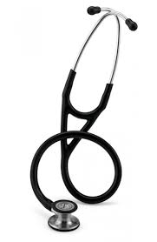  Figure 1 Littman Cardiology IV Stethoscope
Diagnostic set: The recommended product is the Welch Allyn Coaxial Lithium Ion set, containing an ophthalmoscope and otoscope that attach to a lithium ion power handle. Item number 97200-MS. Approximate cost $610.00. | 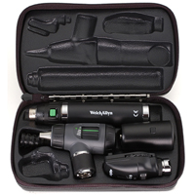  Figure 2 Welch Allyn Diagnostic Set
Sphygmomanometer: The recommended product is the Welch Allyn hand aneroid blood pressure kit with adult and student cuffs. Product code DS58-ST. Approximate cost $210.  Available at www.reddingmedical.com and https://themedicalstore.biz. | 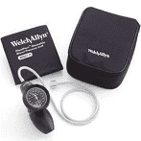  Figure 3 Welch Allyn sphygmomanometer
Digital thermometer: Available from www.steeles.com. Product code 1530. Also purchase disposable thermometer covers; product code 3600. Approximate total cost $14. | 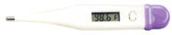  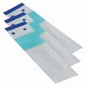  Figure 4 Digital thermometer and covers
Pocket eye chart: Also called a Snellen chart. Approximate cost $2. | 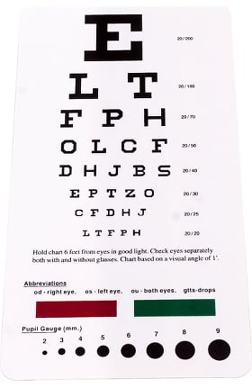  Figure 5 Pocket eye chart (Snellen)
Reflex hammer: Used for examination of the neurologic system. Recommended item is the Babinski telescoping reflex hammer. Approximate cost $13. | 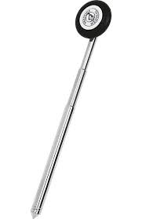  Figure 6 Babinski telescoping hammer
Tuning fork: Used for evaluation of hearing and the neurological system. Select a C-128 tuning fork. | 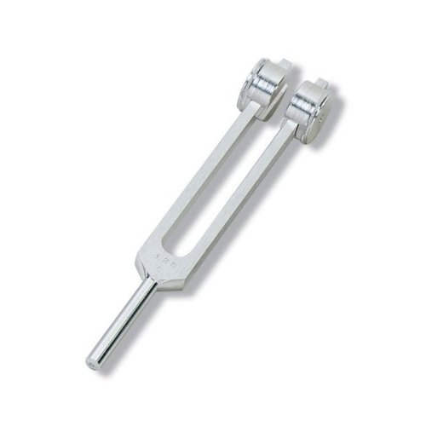  Figure 7 Tuning fork C-128
Monofilament: Used for neurological examination, particularly for diabetic neuropathy (loss of sensation in the feet). Various models available. Recommended item available at www.saveritemedical.com, item code 60-MSC0002. Approximate cost $3. | Figure 8 Monofilament
Cloth measuring tape: Various models available – www.steeles.com or www.allheart.com. Approximate cost $6. | Figure 9 Measuring tape
EKG caliper: Used in interpretation of electrocardiograms. Various models available – www.steeles.com or www.allheart.com. Approximate cost $8. | 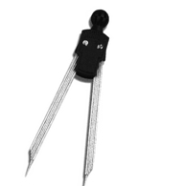  Figure 10 EKG caliper
Bag: Recommend a bag to store and transport your supplies. Various models available online. Nylon bag in various colors with free MSUCOM logo available at www.steeles.com – product code C85215. | 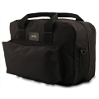  Figure 11 Medical bag

