Adding MSU COM Calendars
to your preferred Google Account

Overview: These instructions will guide you through the process of adding an MSUCOM published calendar to your preferred Google account’s calendar.
- Navigate to Google Calendar (calendar.google.com)
- Sign in with your preferred Google account
  - You can sign in with your personal Google/Gmail account (if you have one), or your MSU account.
To use multiple Google Accounts on the same browser or mobile device, see these instructions from Google.

  - To use your MSU account, type your MSU NetID + “@msu.edu” (e.g. sparty@msu.edu) in the email field, then click “Next” – you will be directed to MSU’s authentication page where you can sign in with your MSU NetID credentials.
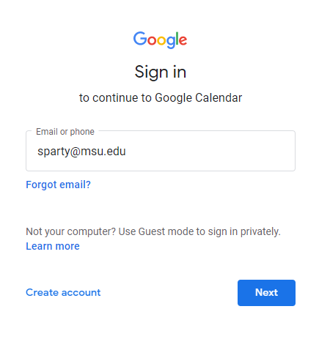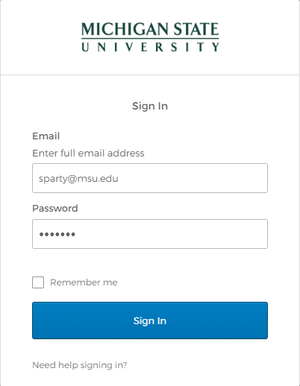
- In a different tab in the same browser, open the COM Class Academic Calendar you would like to add to your Google calendar. Options include:
  - MSUCOM Class of 2026
  - MSUCOM Electives
  - MSUCOM Student Events

- On the page that opens, you will see a small “+GoogleCalendar” button in the bottom right, below the calendar. Click this button to add the calendar to your preferred Google account (see step 2 on choosing your preferred Google account).
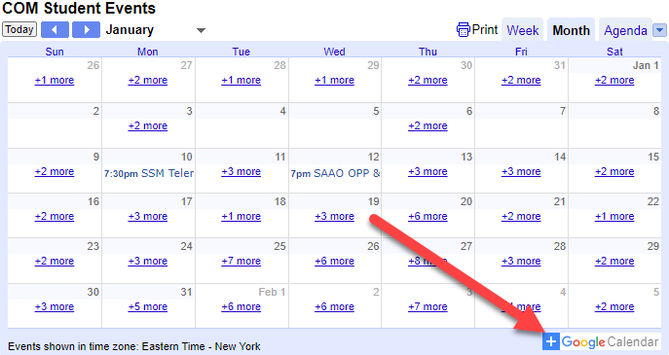

- Your Google Calendar page will open, with a pop up that says, “Add calendar.” Click “Add.” 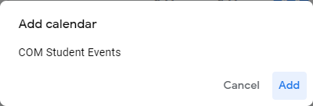
- The newly added calendar will appear in your list of “Other calendars.” You can toggle whether it appears in your calendar view by clicking the check box next to the calendar name.
